Business Lines Report
Business Lines Report is centered on the websites traffic statistics that represent company’s portfolio offers.
The report is sourced using APIs and Google Analytics data and is represented by the following tables:
- BL_API_transformation - r
- BL_Pageviews_dataset – r
- BL_Users_dataset - r
- Index_BL - r
Additional datasets
- Last Refresh Table
- Date Table – for Pageviews table statistics
- Date Table 2 - for Users table statistics

Relationships
Table (column) | Relationship | Table (column) | Status
BL_API_transformation- r (id) | Cardinality:  Many to Many  Cross-filter direction: Both | BL_Pageviews_dataset - r (id) | Active
BL_API_transformation- r (id) | Cardinality:  Many to Many  Cross-filter direction: BL_API filters RLS | BL_Users_dataset – r (id) | Active
BL_Pageviews_dataset - r (Date) | Cardinality:  Many to one  Cross-filter direction: BL_API filters Date Table | Date Table | Active
BL_Users_dataset - r (Date) | Cardinality:  Many to one  Cross-filter direction: BL_API filters Date Table 2 | Date Table 2 | Active

Data model
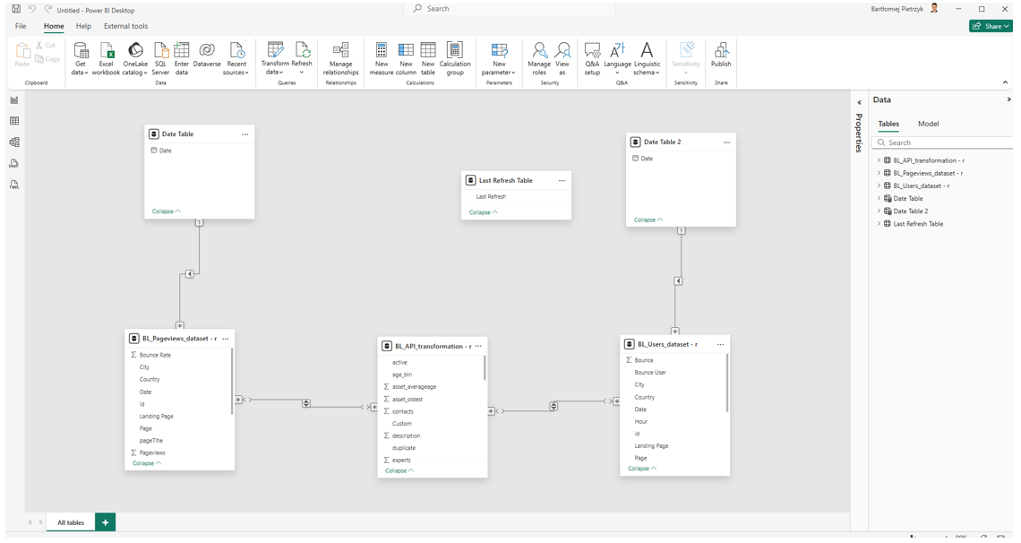

Dataflow architecture
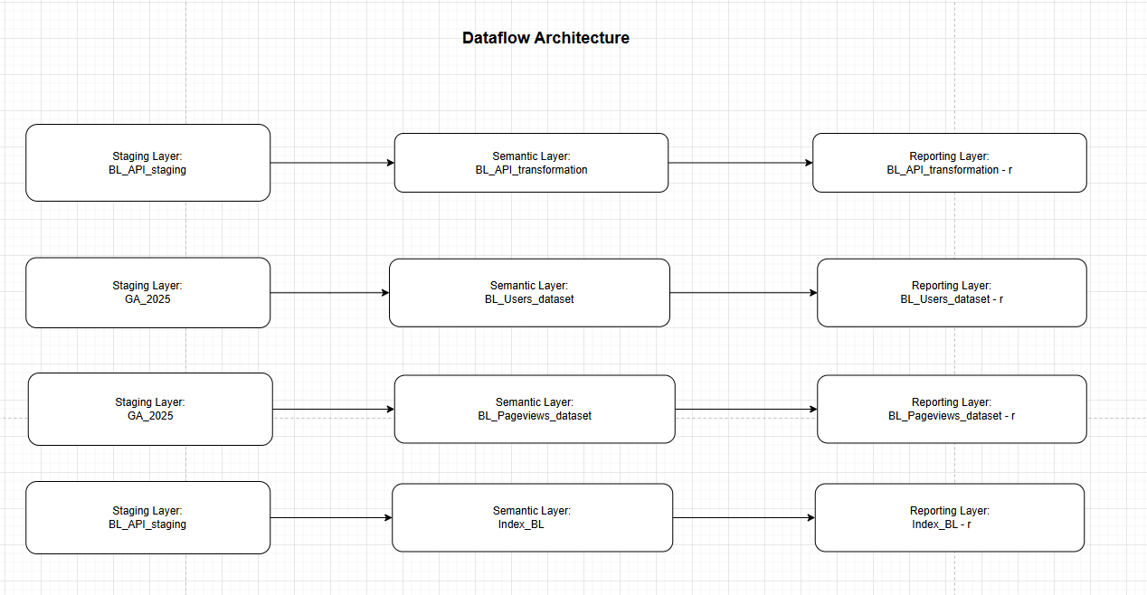

Summary
- BL_API_transformation - r table is joined with BL_Pageviews_dataset - r to meet further reporting needs.
- BL_API_transformation - r joined with BL_Users_dataset - r to meet further reporting needs.
- BL_API_transformation - r table is joined with Index_BL - r to meet further reporting hierarchical needs.
Core functionalities
- Hierarchy
  - Company’s offers are displayed on the website using a hierarchical structure. To replicate this functionality in Power BI, Index table was created to identify offers categorized as core entities. Each of these core entities is then used to generate the corresponding drop-down lists in the report.
- Google analytics data represents different calculations/measures from various perspectives
  - Pageviews tab
    - Pageviews, pageviews by date and core entity, pageviews by country, Average Time on Page, Bounce Rate, First Time Visitors, Users in Total, topmost viewed offers
  - Users tab
    - Users by Country, users by Clients, users by time of date, cumulative users by year, month and user type, bounce rate by user type, filter by users’ type
  - Filters
    - Offer name, offer main entity, country, active [Y/N], year, month
Visual representation
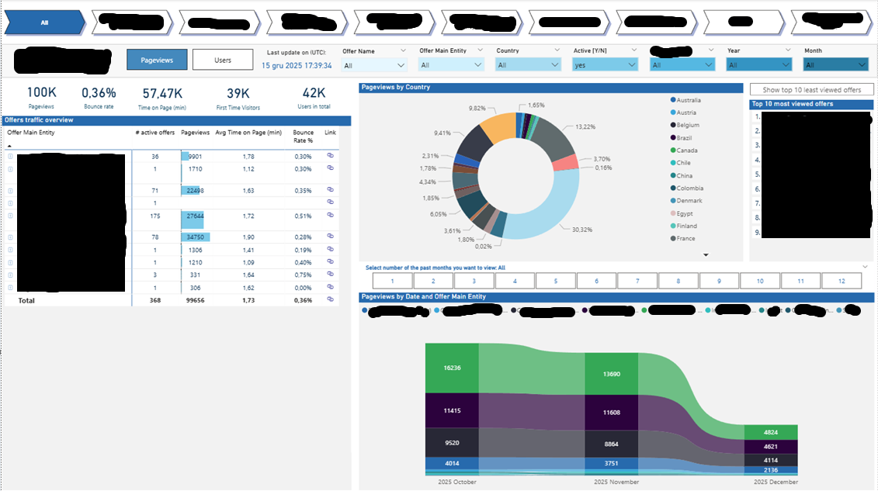
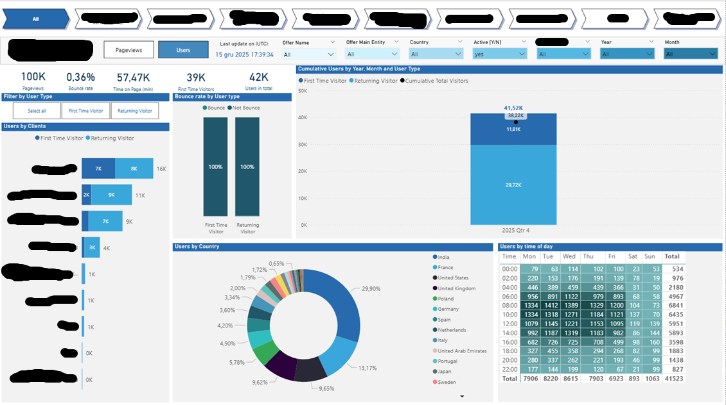

Semantic model creation process
On blank report, I import tables from Datamart.
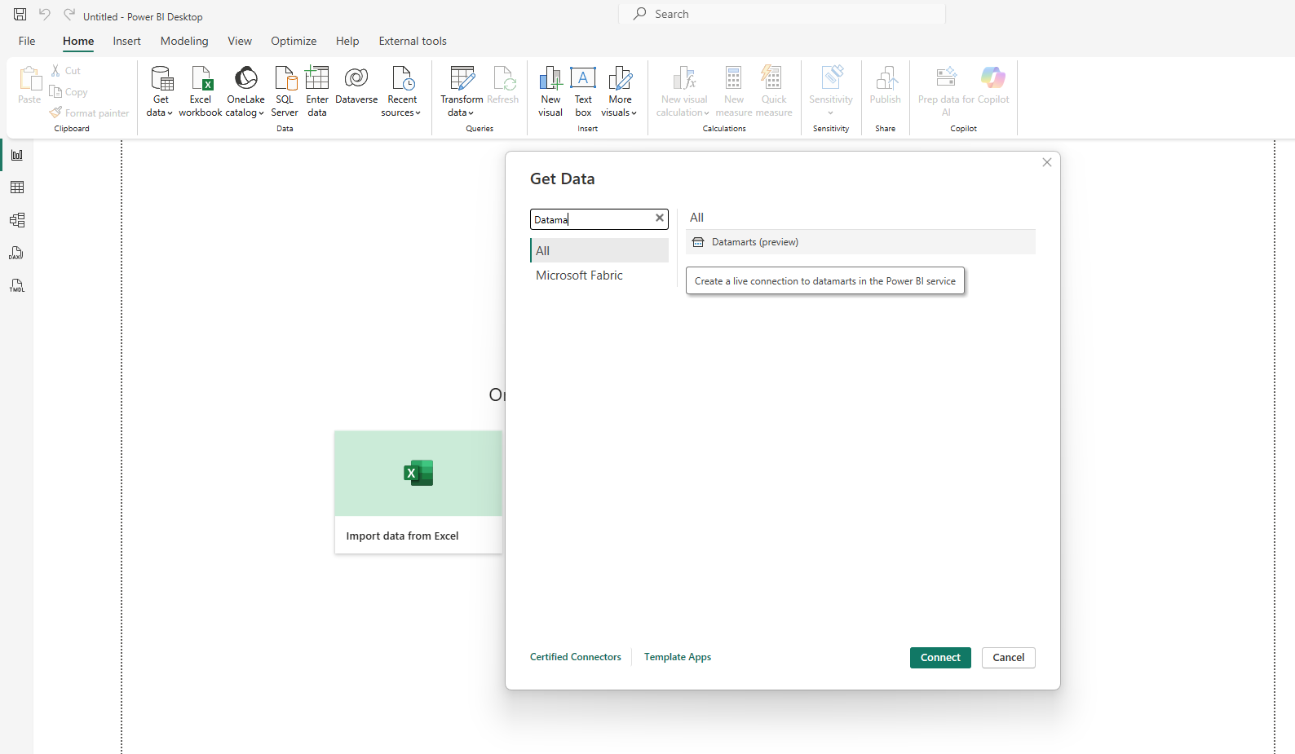
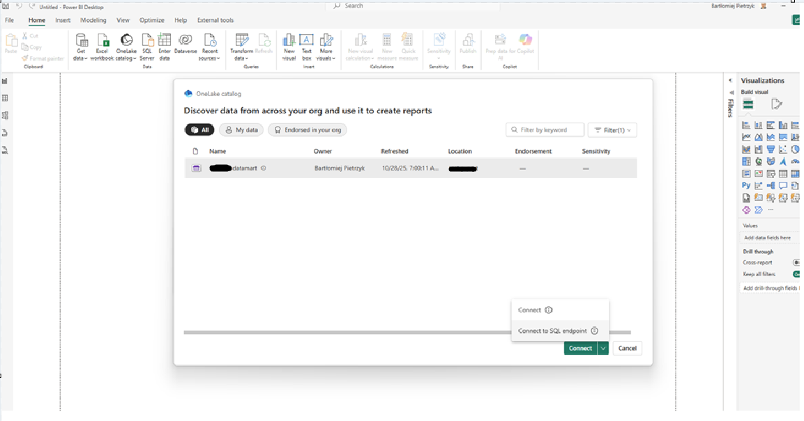

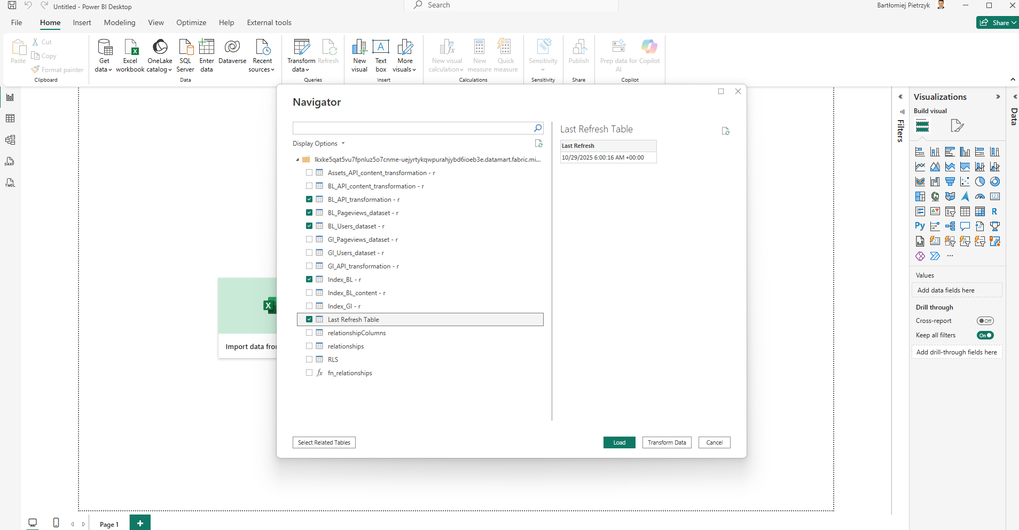
Transform data -> unable load for index -> close and apply -> add date tables
Refer to Global Industries for detailed screenshots of above described.
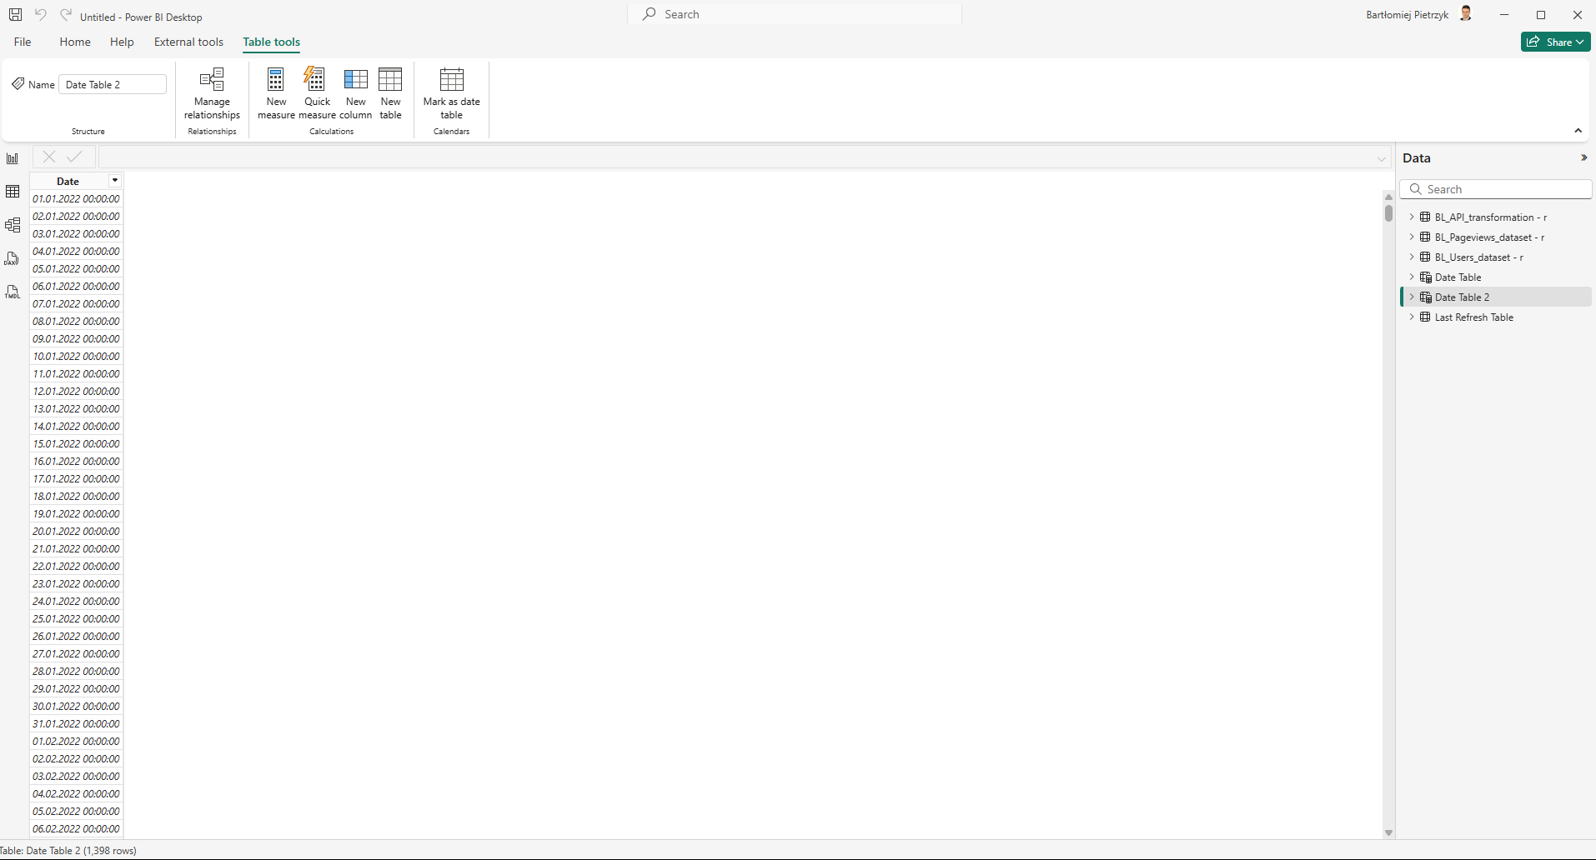

Go to manage relationships and assign accordingly
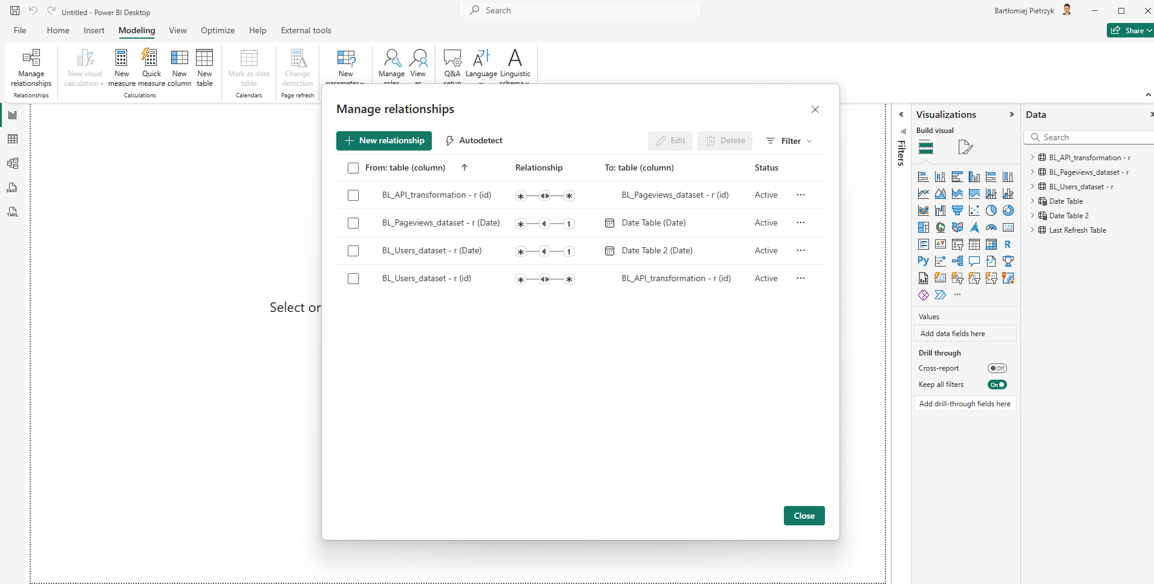
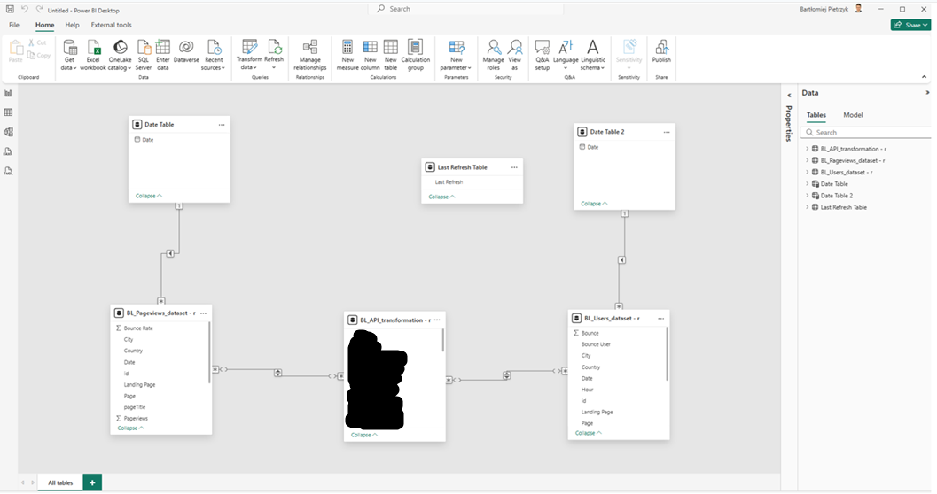
Publish the report to Power BI Service (same process as for BL content report).

